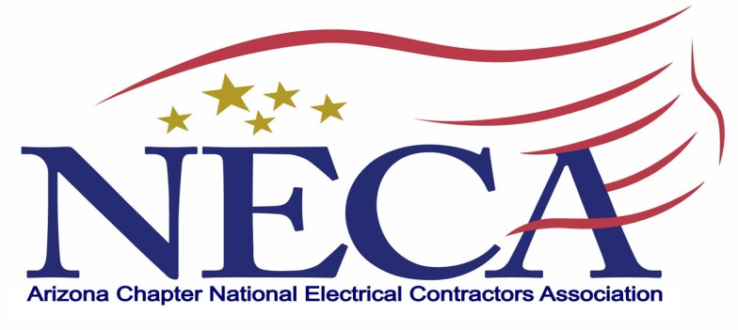
Sponsored by AZNECA Charities
Outstanding Apprentice Challenge

RULES AND REGULATIONS

Apprentice Start-Up Business Challenge for PEJATC

“Create a Winning Business Plan”

Start-Up Challenge Program Manager:

Debra Margraf
Executive Director
Arizona Chapter NECA
4315 N 12th Street, #100
Phoenix, AZ 85014
602-263-0111 Phone
602-263-0447 Fax
debra@azneca.org
Start-Up Challenge Rules
Participation
- All communications should be directed to Debra Margraf, debra@azneca.org
- Apprentice participation is limited to apprentices actively enrolled and in good-standing with the PEJATC. Our winning team will be submitted for the NECA National Apprentice Competition (held in conjunction with the NECA Convention), the ELECTRI’s competition, where the ELECTRI winning team will be eligible to take part in the selected on-site presentation at that January meeting (on odd years, 2021, winning Start-Up Challenge to present at NECA NOW).
- Apprentice teams are expected to consist of not more than two team members and are encouraged to engage fellow apprentices, including those in other classes/years.
- Each apprentice team may submit only one entry or model Business Plan for the competition.
- Submittal must be delivered to the PEJATC offices no later than close of business on May 29, 2020.
External Input
- Each qualifying apprentice/team will present a Business Plan to the AZNECA Charities selection committee. The qualifying presenters will show proof of review with at least 3 local NECA contractors.
- The successful Business Plan must be original and have been prepared by presenter(s).
- All presenters are expected and encouraged to gain input and feedback on their proposal from NECA contractors, vendors, materials suppliers, and JATC Faculty or Training Directors.
- No presenter is permitted to have earned wages for participating in the competition or wages for working on the project selected by the team.
Apprentice Conduct/Business Plan Rubric
- Apprentices are expected to conduct themselves in a professional manner in all aspects of the competition.
- Apprentices are expected to plan visits and phone calls with all advisors in a professional manner that is not disruptive to the activities of the organization (NECA Contractors, Banks, financial advisors, etc.).
- Start-Up Challenge participants are expected to represent accurately the goals and intent of the competition in any website and publication materials they use to develop sponsorship opportunities and outreach messages about their participation in the competition.

Start-Up Challenge Scoring Rubric
Present and address the following components in written form:

Banking/Bonding/Insurance/Legal/Finance (20pts.)
- Corporate Structure
- Financing
- Collections & Cash
- General Liability/Workers Compensation/Insurance Needs
- 5-year Projection
Safety (20pts.)
- Safety Policy
- Cost Containment Processes
Business Development/Strategy (20pts.)
- Target Markets
- Marketing Strategy
Operation Model (40pts.)
- Pre-fab
- Labor Force
- Productivity/Labor Tracking
- Pricing Structure/Estimating Systems

- Video presentation of written business plan is encouraged in initial selection process.
Sponsorship / Awards
- Apprentices are encouraged to seek financial sponsorship to support costs associated with the development of the proposal.
- The winning team will be awarded a full scholarship for the 3 participants on the team. The scholarship will consist of tuition and books for one year of classes. The tuition and book fees will be paid directly to the PEJATC on behalf of the winners.
Start-Up Challenge Committee
The competition committee will be named by AZ NECA and will include contractors and non-bargained employees of AZ NECA members. The three participant teams will make an oral presentation to the AZ NECA board.

AWARDS

The winning team will be entered into the NECA National Apprentice Competition and the ELECTRI International annual competition.

